**1.Joins:**

* Joins are used with select statement.
* It is used to retrieve data from multiple tables from same database.
* It is performed where fetching the records.
* Fetching the records from different tables will be very easy.

**There are 3 types:**

1. **Inner join (simple join)**
2. **Outer join (1.left outer join, 2.right outer join)**
3. **Right join (similar way of right outer join)**
4. **Self join**
5. **Cross join**
6. **Inner join:** In order to return all rows from multiple tables where the join condition is satisfied.

* This is the most commonly used joins in Mysql

**Syntax:**

Select columns from table1 inner join table on table1. Col1=table2.col1;

**Example:**

create table student(studentid int(20) primary key,firstname varchar(45),lastname varchar(50),Age int(50),mail varchar(65));

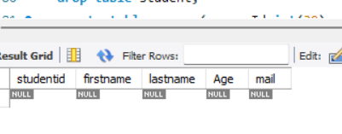

insert into student values ('1','Archana','Gudla',21,'archana11@gmail.com'),('2','Rachana','Rudhra',25,'rachana22@gmail.com'),('3','Chaithu','Chandham',19,'chaithu33@gmail.com'),('4','Thrishu','Manthena',17,'thrishu44@gmail.com'),('5','Madhu','Panjala',24,'madhu55@gmail.com');

select * from student;

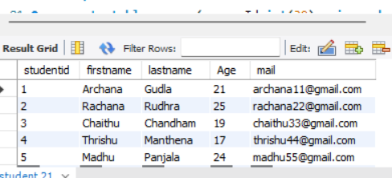

create table course(courseId int(30) primary key,courseName varchar(40),studentid int(10),foreign key (studentid) references student (studentid));

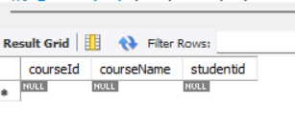

insert into course values('101','Hr','1'),('102','Java','2'),('103','Python','3'),('104','C++','4'),('105','devops','5');

select * from course;

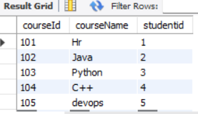

**select firstname,lastname,age,courseName from student inner join course on student.studentId=course.studentId;**

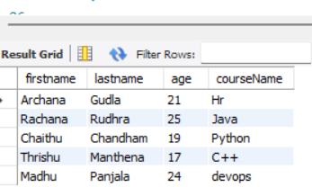

**2.Outer Left Join:** Return all rows from left hand side table and all the rows from right hand side table by satisfying the join condition.

**Table1 Table2**

These will both combine all will be accommodate to the left hand side.

**Syntax:** Select cols from table1 left outer join table2 on table1.col=table2.col;

**select firstname,age,mail,coursename from student left outer join course on student.studentId=course.studentId;**

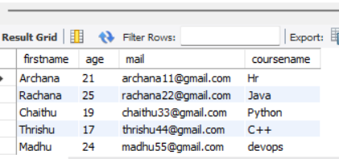

1. **Right outer join (or) Right Join**: Return all rows from the right hand table with right hand table rows. On to the right table by satisfying the condition.

**Syntax:** select cols from table1 right join on table2 on table1.col=table2.col;

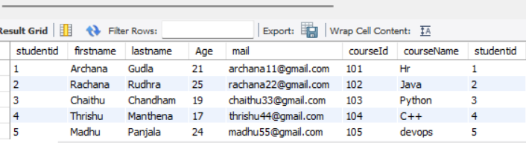

select *from student right join course on student.studentId=course.studentId;

1. **Self Join:** The data/rows in the table are combine/joined with the same data/rows in the same table.

**Syntax:** select col_name from table1,table2 where condition;

**select * from student self join student;**

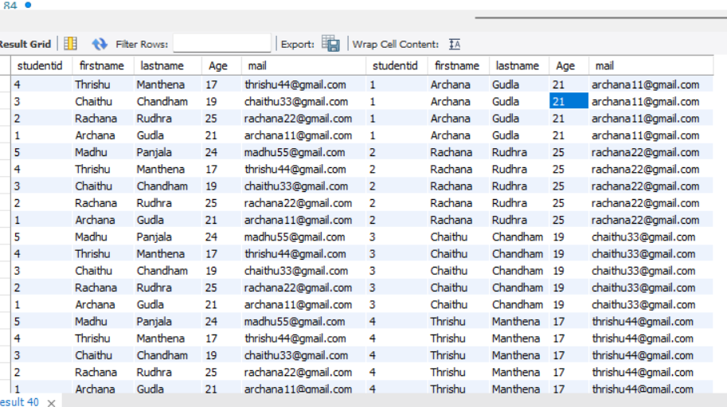

1. **Cross join:** Return all the records from both the tables (table1 & table2)

**Syntax:** select col_name from table1 cross join table2;

**select firstname,age,courseId,courseName from student cross join course;**

